Acknowledgement

This Project shall be incomplete if I fail to convey my heart-felt gratitude to those people whom I received considerable support and encouragement during this project creation. Lots of people have helped, provided technical, commercial and also behavioral acumen at all levels of the project and it`s my luck for get the kind of support of them.
I have no words to thanks to our project faculty Mr. P.B.Thakkhar for help. Also grateful to H.V.Shah Sir and R.D.Vanazara Sir for their time and help . They are becoming as way to take us from dark to bright future and specially they play their important role for motivation and to endeavor for succeed in project creation.
I want to say thank to all staff of UVPCE for support us indirectly to build this project. They provide us atmosphere and necessary tools which we required.
I want to especially thank to my classmates for suggestions and good support.

Pathan Mo Karimkhan Y

Abstract

This is Network based project to deal with network and cop up with the packet transfer and content of the packet . Packet transfer is done here using java networks API java concept .Here in this project is based on jpcap library , which is open source library for java which provides different packages and class to capture the packets from the network . Here we can get network interface and then selecting particular interface we can capture the packets from that interface . After getting interface we have created the jpcapcaptor class and its instance is capture . We have to setup path for jpcap files and set the jpcap.dll and jpcap.jar file in system files .
Then we have created the Packet class and it’s instance is pack . Now value of the pack is assigned by the instance of jpcapcaptor and using getPacket() method . Captor is the instance of jpcapcaptor class and it contains interface value , size of the packet that we want to capture and true or false based on promiscuous or not promiscuous mode . True if we want to open the interface in promiscuous mode, and otherwise false. In promiscuous mode, we can capture packets every packet from the wire, i.e., even if its source or destination MAC address is not same as the MAC address of the interface you are opening.In non-promiscuous mode, we can only capture packets send and received by your host.
Then we capture the packet then using instance pack of Packet class and get data , header and all the values related to packet . here whatever values we get are in different format so we need to convert in that format and place in text field to see.
Some of the valued we get in ASCI so we need to convert into String and readable form .
Index

1 . Introduction 1
  - Overview of the project 4
  - Scope of project 4
  - Purpose of project 4
2. Hardware and Software requirements 6
2.1 Hardware requirement 7
2.2 Software requirement 7
3. Project planning 8
3.1 Requirement analysis 10
3.2 System design 10
3,3 Implementation 10
3.4 Testing module 10
3.5 Modules of project 10
3.6 Project scheduling 11
4. UML diagrams 12
4.1 Class diagram 13
4.2 Activity Diagram 14
4.3 Usecase Diagram 17
5. Snap Shot and short description 18
6 . Further Enhancement 25
7 . Conclusion 26
8 . References 28 -29

1.
INTRODUCTION

  - Overview Of Project:

- Purpose of this tool is to make such a tool which allows us to sniff the packet from the network and analyze the packet . This application easily identify result of capturing the different packets from networks .
- Diagram given in the report shows the flow of the project and object and classes in the project .

- Each snapshot given below describes here how to capture the packet what captured packet contains Fields of all the packets and all capturing of perticular packet .

- Here we also make GUI (Graphical User Interface) for this application where user have to select the type of packet that he has to captured . there is radio button list from which user select the packet type and click on the capture so packet related to perticular protocol get captured and listed .

- Further use of this application is in networks monitering . When persons are communicating the data or two or more PC’s transefering the data at that time adminnister can notice that what is happening in the networks .

  - SCOPE OF PROJECT:

- We use here only TCP , UDP , ICMP , ARP and RARP packets only . Other packets can not be identified from this application .

- Also we have a limitation of visulatation of some of the fields as they are in ASKI code so String form not given readable contains as well some byte and boolien type data can not be put in textfield as it contains only String .

- GUI shows the reslut of capturing the packet but fields given are of the last captured packet . Because when one by one packets get captured and set into the filed , on next packet arival it get over written . In full archive all captured packets are shown .
  - PURPOSE OF PROJECT:

- Retrive the payload of the packet when two or more parties are communicating in the project . When there is login systen LAN connection that it can help admin to protect the change of password from unauthrizes entity .

- This application is useful to identify and separate different packets from network . Notice the different fileds of packet .

- Further use of this application can be used to moniter the traffic of the networks . Which types of packets are getting transferred and moving in the networks

- This application of concept is also useful retrieving the details of each packets moving in the network . Like source IP , Destination IP , Source and detination port , data and header length , fregmenation bits ,protocol type and value , version of the packet whether ipv4 or ipv4 and other fields related to packets .

2.
HARDWARE AND SOFTWARE REQUIREMENTS

2.1 HARDWARE REQUIRMENT:
- 450MHz of CPU Speed
- 20 GB of Hard-disk Space
- 512 MB of RAM

2.2 SOFTWARE REQUIRMENTS:
      - Jdk 1.6 , java run time environment
      - Netbeans
      - Jpcap library
      - Jpcap
      - winpcap

3.
PROJECT PLANNING

- Project planning includes description of project tasks , activities and functions, dependencies, resource requirements and a detailed schedule. This activity results in the software project management plan for the website.

Design
Coding
Testing
Requirement
Analysis

3.1 Requirement Analysis:

  - The requirement analysis activity takes the problem statement and reviews it in terms of consistency, completeness and feasibility.

3.2 System Design:

- The purpose of the system design activities is to devices a system architecture that maps the analysis model to the chosen target environment. The major part of the system design phase is design of subsystems, that is, the decomposition of the system with respect to the chosen target platform. The system design activity also refines the Use-cases from the analysis model and describes in terms of interaction diagrams how the objects interact in each specific Use-case.

3.3 Implementation:

- The focus of this activity is on coding the individual objects described in the object design document.

  - Testing Module:

- At the end of each and every phase is on coding the individual objects described in the object design document.

  - MODULES OF PROJECT:
User Module :

Identify the networks interface and select interface in which you want to capture the packet . So list the available interface in the netoworks .

Listen the network to capture packets from netowork and capture the packet from perticular interface

List the different packets name and field of the packet and provide GUI to select
and retirve the packets.

Retrieve the different fileds of the packets and set the values in perticular field as well append the contains of all the packets to get full archive .

3.6 PROJECT SCHEDULING:

  - First Month (June):

Searching for project definition and Decided project definition in first two weeks. Analysis of the project and on its bases divided the project into different modules.

  - Second Month (July):

Analysis of the modules and collected information from browsers.
  - Third Month (August):

Started coding establishing connection and getting interface of the computer . Started try for capturing packets going out and coming to computer . on the second module
Extracted interface of the PC including microsoft and ethernet adapter interface and tried to capture packets from this interface . but it was giving null values only .of the project.
  - Forth Month (September):

Started use of jpcap library to capture the packet , installed jpcap , winpcap and tried to capture the packet from internet . But it was showing error . Took little bit time to set the path and setting jpcap files in the sytem files . (jpcap.dll,jpcap.jar) . Initially giving junk code as a payload of the paket . Then connected PC and LAN transferred data in LAN connection and then tried to capture the packet . Capturing the packet and giving junk codes as a out put . Then make a user client communication between two PC and tried to capture the packet . Which also gave junk characters . Then using individual packet and focusing on individual packet tried to capture the packet and content of packet .

  - Fifth Month (October):

Separated all the packets and capture the payload , source – destination address , and other filed . Made user interface file . Created GUI to facilitate the user friendly packet capturing .

4.
UML DIAGRAMS

  - CLASS DIAGRAM:-
A class diagram is a picture for describing generic descriptions of possible systems. Class diagrams and collaboration diagrams are alternate representations of object models. Class diagrams contain classes and object diagrams contain objects, but it is possible to mix classes and objects when dealing with various kinds of metadata, so the separation is not rigid we applied that concepts over here. In Packet sniffer the class diagram depicts the way classes are interrelated to one another and dependency among the class with their attributes towards them. The relationship among them depicts the way they are interlinked with each other. So the Class diagram plays an important role in sequence diagram as the function of class diagram is used in sequence diagram.

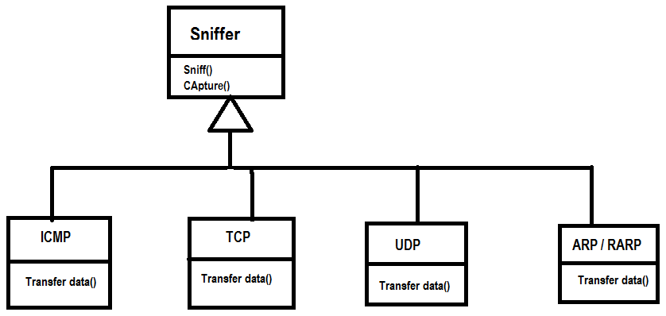

4.2 ACTIVITY DIAGRAMS :

- Activity diagrams are diagram technique showing workflows of stepwise activities and actions, with support for choice, iteration and concurrency.

  - In the Unified Modeling Language, activity diagrams can be used to describe the business and operational step-by-step workflows of components in a system. An activity diagram shows the overall flow of control.

- Activity diagram shown here consist of:

- Initial node.
- Activity final node.
- Activities

- The starting point of the diagram is the initial node, and the activity final node is the ending. An activity diagram can have zero or more activity final nodes. In between activities are represented by rounded rectangles.

Notations Of The Symbol Used In The Diagram:

- Activity: 

- Starting position: 

- Control Flow: 

- Ending position: 

- Decision:

User

Select Protocol

Click Capture

All packets
Packet Sniffer
Selected packet
Start

Null

Capture Packets

View GUI

4.3 USECASE DIAGRAMS :
A use case diagram in the Unified Modeling Language (UML) is a type of behavioral diagram defined by and created from a Use-case analysis. Its purpose is to present a graphical overview of the functionality provided by a system in terms of factors, their goals (represented as use cases), and any dependencies between those use cases.
The main purpose of a use case diagram is to show what system functions are performed for which actor. Roles of the actors in the system can be depicted.
Notations of the symbol used in the diagram:

Actor :

Use Case :

Connector :

Packet Sniffer & analyser

Select Protocol
Click Capture Packet
User

Select Interface

Select Fields

5.
SNAP SHOT WITH SHORT DESCRIPTION

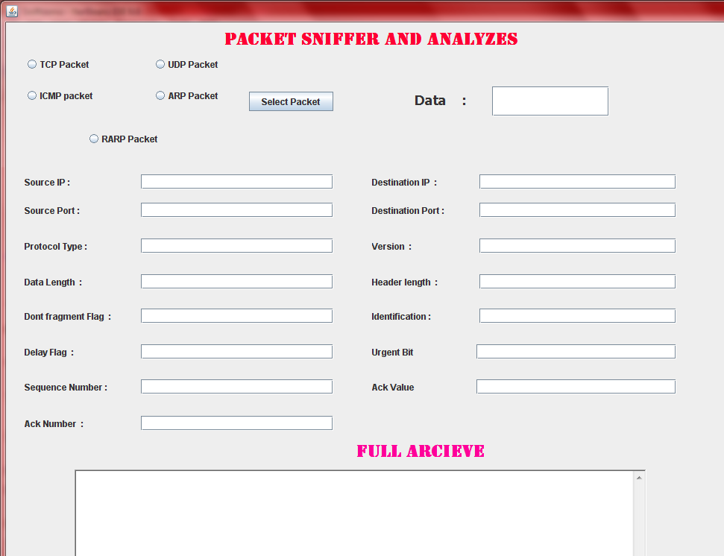

Available choice and fields too be retrieved .

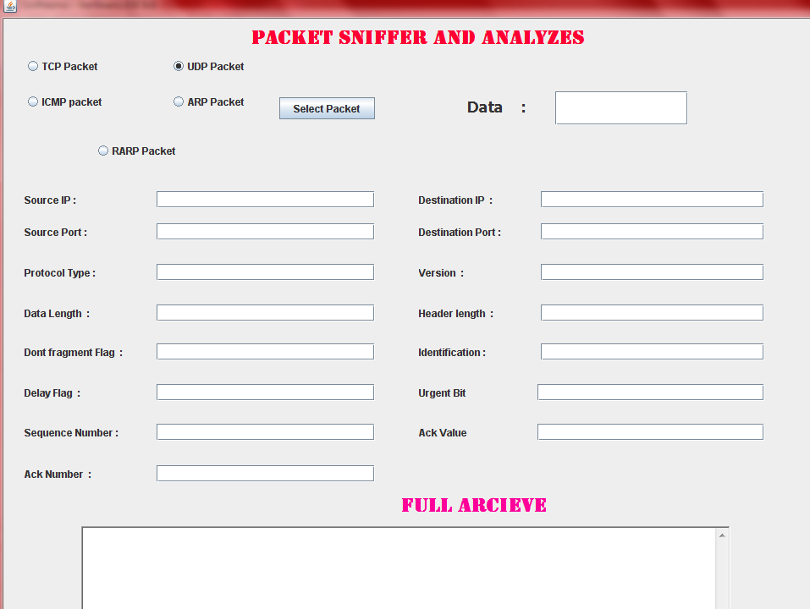

Select the protocol that you want to capture .

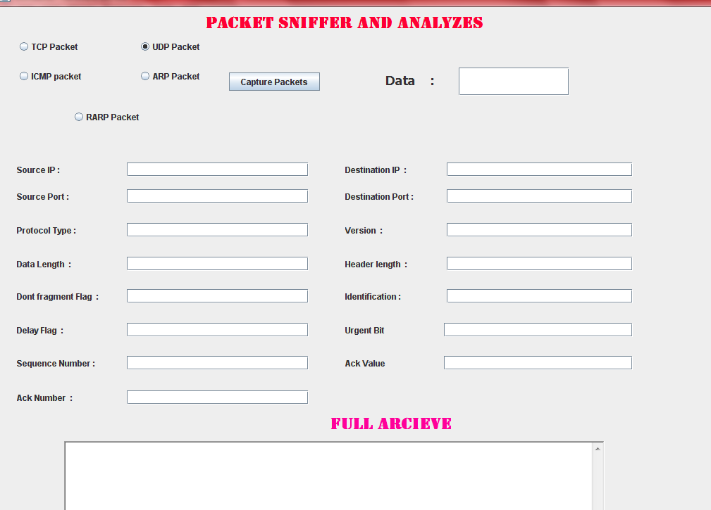

Click capture packet to capture the packets .

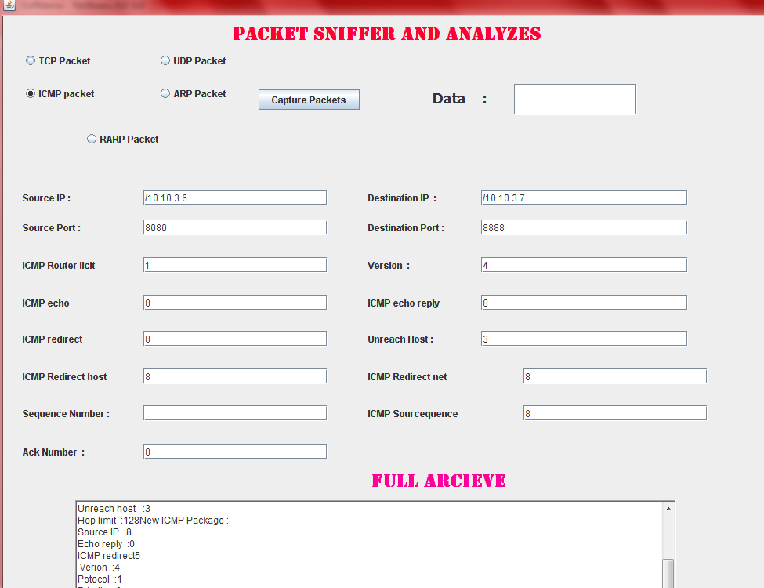

Value of the different filed for ICMP packet is retrieved

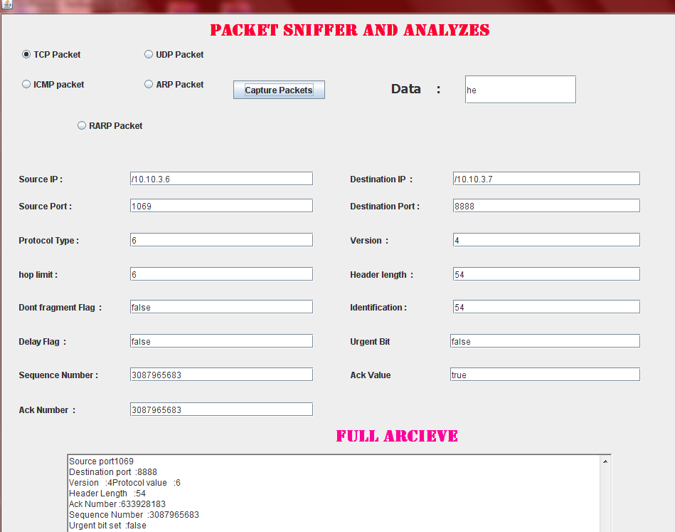

Captured Data for IP packet
.

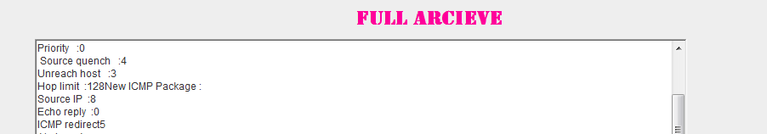

Full archive shows the details of all the retrieved packet.

6.
FURTHER ENHANCEMENT

- This application can be further enhanced by installing it on server System and then focusing more on TCP and UDP packet so that all the data transferred can be achieved and monitored .
- Implementing same code for ICGP we can monitor the groups messaged send and received by router . But for that we have to have router access .
- Show online, on some domain how to use this utility and sniff the packets from networks

7.
CONCLUSION

This is Network based project to deal with network and cop up with the packet transfer and and content of the packet . This project is based on jpcap library , which is open source library for java which provides different packages and class to capture the packets from the network . Here we can get network interface and then selecting particular interface we can capture the packets from that interface . After getting interface we have created the jpcapcaptor class and its instance is capture .
Then we have created the Packet class and it’s instance is pack . Now value of the pack is assigned by the instance of jpcapcaptor and using getPacket() method . Captor is the instance of jpcapcaptor class and it contains interface value , size of the packet that we want to capture and true or false based on promiscuous or not promiscuous mode . True if we want to open the interface in promiscuous mode, and otherwise false. In promiscuous mode, we can capture packets every packet from the wire, i.e., even if its source or destination MAC address is not same as the MAC address of the interface you are opening.In non-promiscuous mode, we can only capture packets send and received by your host.
Then we capture the packet then using instance pack of Packet class and get data , header and all the values related to packet . here whatever values we get are in different format so we need to convert in that format and place in text field to see.
Some of the valued we get in ASCI so we need to convert into String and readable form .
We can enhance this for IGMP and some other protocols and monitor network . Enhancing the code we can achieve payload of all the packets from the network and all the data in place of here we getting communication payload .We can use it to Show online, on some domain how to use this utility and sniff the packets from networks .

8.
REFERENCE

8.1 Books

TCP/IP Protocol shite
(Behrouz A. Forouzan)
8.2 Websites
Www.google.com
www.sourceforgeget.com
www.jpcap.com

